|  |
| --- |
| Photo displaying partial image of two pie charts on a canvas-textured page |
| Epilepsy Diagnosis Using EEG Signals  [PR] Final Project |
| |  |  |  | | --- | --- | --- | |  | 3/16/19 | Pattern Recognition | |

Contents

1. Introduction 2

2. Objective 2

3. Methodology 2

4. Dataset 2

5. Preprocessing (Given) 3

6. Feature Extraction 3

7. Classification Algorithms 3

8. System Performance Evaluation 3

9. Deadline 3

10. Support 3

# 1. Introduction

* Epilepsy is a group of neurological disorders characterized by epileptic seizures.
* Epilepsy Seizure is a brief episode of signs or symptoms due to abnormal excessive neuronal in the brain. Also defined as the result of a transient and unexpected electrical disturbance of the brain. Seizure may be body shake, quickly eye movement … and so on.
* The diagnosis of epilepsy is typically made based on observation of the seizure onset by two methods: an electroencephalogram (EEG) to look for abnormal patterns of brain waves, and neuroimaging (CT scan or MRI) to look at the structure of the brain.
* EEG signals are the brain signals which record the electrical activity of the brain, as shown in Figure 1. EEG is most often used to diagnose epilepsy, which causes abnormalities in EEG readings. From this signal we can know more information about the human such as if that human has epilepsy, autism, focusing on something, or sleeping … and so on. It is safe and painless.

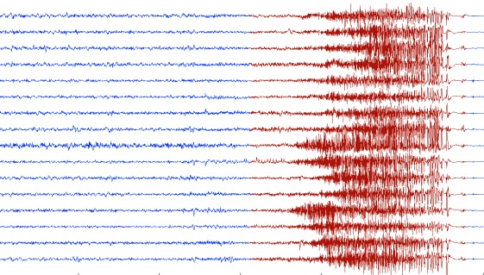

Figure 1 EEG Signal

# 2. Objective

The goal of this project is to build a diagnosis system that can pick out and identify whether a person has epilepsy or not from an input EEG signal, as shown in Figure 2, based on the registered samples.

# 3. Methodology



Figure 2 Methodology

# 4. Dataset (Original)

* A real-world data, consists of 500 patients.
* Patients are equally divided into 5 sets (Z, O, F, N, S) (i.e. 100 patients each)
  + **Z** for healthy people in relaxed and awake state.
  + **O** for healthy people with eye movements.
  + **N** **& F** for interictal people.
  + **S** for ictal people.
* Each file contains 4097 values, in .txt file, which represents the brain activity for 23.6 secs.
* **Z and O** sets represent **normal** people. While **N, F and S** represent **up normal** people.

# 5. Preprocessing (Given)

This is actually what you have, check the dataset folder for more details

* After preprocessing the dataset, the dataset now consists of 2000 samples (400 samples per set).
* Now, each set is stored in only one text file, in which each row represents a sample.
* In addition, each sample is described by 20 values (features).

# 6. Feature Extraction

The given dataset consists of the extracted features.

# 7. Classification Algorithms

Implement the following learning algorithms in ONE package:

1. **Bayes Classifier** 
   * Try different splits in Maximum likelihood Estimate (MLE)
2. **K-Nearest Neighbor** 
   * Try different K values
3. **Multilayer perceptron (Neural Network)**

* Consider building a generic structure, such that
  + Input = #features
  + #layers = input (could vary)
  + #hidden units = input (could vary)

# 8. System Performance Evaluation

* Overall Accuracy use it to obtain the **accuracy** of a classifier, by counting the number of test samples were correctly classified (i.e. classified the same in the actual and predicted classifications), and then dividing this by the total number of test samples.
* You have to pay attention to the following:

1. Code, you must deliver optimized code (Vectorize the code as much as possible).
2. Package structure, you must organize the package into files and each file into functions.

* Deliver a comparison table shows the accuracy for different learning algorithms

# 9. Deadline

• Delivering the whole project will be in the practical exam week.

# 10. Support

• There will be a support labs for answering your inquiries. It is supposed to be the last lab

Good luck! ☺